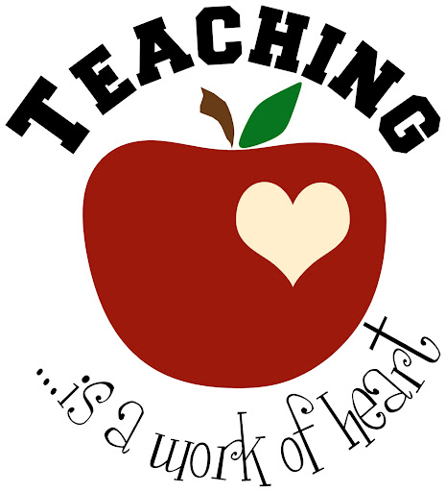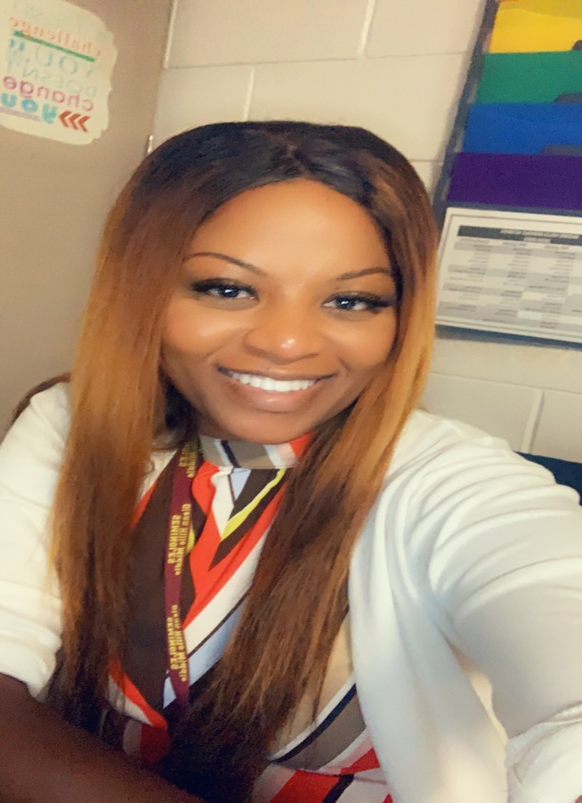

**WELCOME STUDENTS to Mrs. Moody’s class 2021-2022!!!**

I am thrilled to be your I-Ready math or ESOL teacher. This year is going to be fun, exciting, and adventurous. I need for you to come in **READY** to learn with your *Thinking Cap* on. It is my goal to support and guide you to success. Together we can do this!

I have been teaching for three years, however; I have been working for the school system for eight years. We all have been through unprecedented time this past year, but as your teacher, I will provide you with support to meet your education needs. I look forward to seeing your smiles and working with you. Welcome to GHMS where we strive to reach to the hill!

You can reach me via email: moodyca@boe.richmond.k12.ga.us

**Required Classroom Materials**

* Earphones
* Composition Notebook